IANR Annual Merit Recommendation Form Instructions
2/16/17

The IANR Annual Merit Recommendation Form (Merit Form) was developed to bridge the IANR Staff Performance Management process to the annual Merit Increase Process. A presentation with detailed information and instructions on how to complete the Merit Form is located at ianrhr.unl.edu and should be reviewed prior to completing a Merit Form.

It is important to keep in mind this is a recommendation. The final merit increase decision is made by the Unit Administrator.

Steps for Supervisors:

- Merit Form is Distributed
- The form will be sent to supervisors by their Business Manager by March 1 each year. The form can also be found at ianrhr.unl.edu.

- Complete the Merit Form
- One form should be completed per supervisor.
- The form should be completed by the immediate supervisor using all performance-related information sources available to them since the last merit form was completed.
- All regular, staff employees you supervise should be listed on the form in one of the three areas as explained on the form:
- Exceed expectations
- Fulfill expectations
- Did not meet expectations

- Return the Merit Form
- Return the form as instructed by your Business Manager by March 31.
- The Merit Form is a “summary” document and it is critical that any merit recommendation is supported by back-up documentation. However, the supporting documentation does not need to be attached unless required by the Unit Administrator.

Questions related to Performance Management or completing the Merit form should be directed to:
Rachel Szelag – IANR HR Specialist
rszelag2@unl.edu
402.472.6837

Questions related to merit should be directed to your Business Manager or the IANR Budget Office.
Bryan Areman, IANR Finance Director
bareman2@unl.edu
402.472.1420
IANR Annual Merit Recommendation Form (Merit Form)
2/16/17
Date Completed:

Supervisor Name: |  | Department:

Fulfilled performance expectations; high quality performer

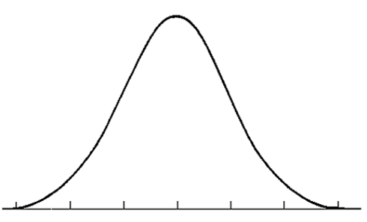
Exceeded expectations; performed above and beyond
Did not meet expectations; opportunities for improvement

NOTE: Rows can be added or removed in each section as needed depending on the number of employees supervised.

List the names of employees who have EXCEEDED EXPECTATIONS. These employees consistently exceed expectations with performance above and beyond the majority of their peers. Only a few employees in the workgroup should exceed expectations and it is possible there won’t be any employees listed in this section. For each employee listed, please provide justification to support the recommendation.
Employee Name | Justification

List the names of employees who have FULFILLED EXPECTATIONS. These employees consistently meet expectations and are high quality performers. The majority of employees in the workgroup should be listed in this section. No additional justification is needed for these employees.
Employee Name |  | Employee Name

List the names of employees who DID NOT MEET EXPECTATIONS. These employees have areas of needed improvement. It is possible there won’t be any employees listed in this section. Documentation must support this recommendation and it should not be a surprise to the employee. For each employee listed, please provide justification to support the recommendation and note whether IANR HR has assisted you with addressing the employee’s performance concerns.
Employee Name | Justification | IANR HR (yes/no)
Once completed, this form should be returned by March 31 as directed by your Business Manager.

