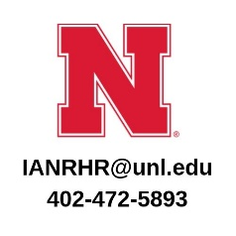
Performance Management Conversation

Employee:
Manager:
Position:
Review Period: December 1 – March 15, 20
July 1 – October 15, 20

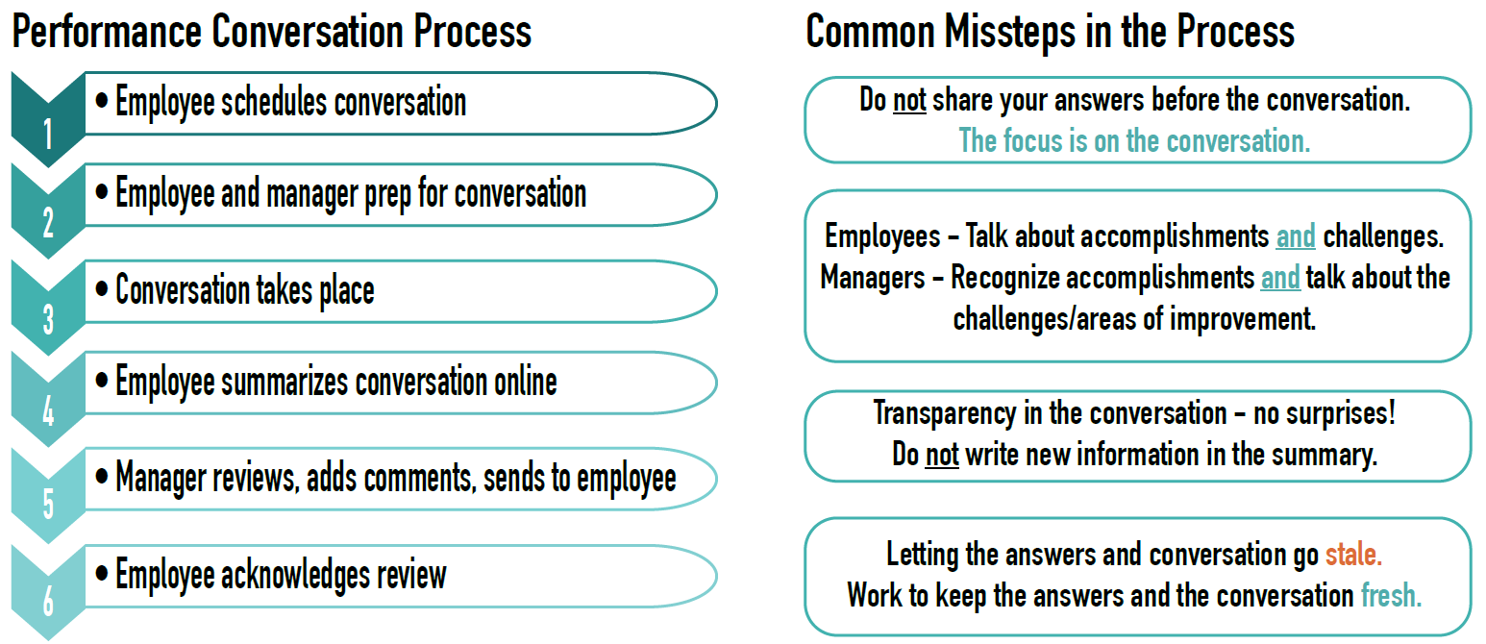
1. What accomplishments have you had since the last time we met?
Things to think about: This is your opportunity to highlight what you accomplished over the past six months. You do not need to list everything you achieved but focus on the projects or tasks that were your biggest priority; you were most proud of achieving; had a significant impact; or has been most beneficial to the department/team.
Go to https://ianrhr.unl.edu/what-accomplishments-have-you-had-last-time-we-met for ideas to keep the answer fresh
2. Do we (me and my supervisor) think my accomplishments align with what is expected (most needed) for this position and our unit's priorities? Yes, Somewhat, or No? Explain.
Things to think about: Are we on the same page for how I should be spending my time? Why or why not? What are the expectations for this position? Remember that priorities and workload shift throughout the year. It is okay to be flexible and adjust your goals as necessary.
Go to https://ianrhr.unl.edu/do-we-think-my-accomplishments-align-what-expected-position-and-our-units-priorities for additional things to think about for this question
3. What will you accomplish before the next time we meet?
Things to think about: Think ahead to the next six months. What are the things you will be working on? What projects or tasks will require most of your time and/or will have the biggest impact? Work with your supervisor to clearly define what is expected of you in your current job.
Go to https://ianrhr.unl.edu/what-will-you-accomplish-next-time-we-meet for ideas to keep the answer fresh
4. What are your natural strengths and talents? How can you further utilize these in your job and within our team?
Things to think about: During which tasks/projects were you "in your zone?" Which part of your job gives you the most energy? What traits helped you succeed? What are ways you can further develop and invest in your strengths and talents? How can we further tap into your strengths to help our team?
Go to https://ianrhr.unl.edu/what-are-your-natural-strengths-and-talents for ideas to keep the answer fresh
5. What challenges are you facing today?
Things to think about: Are there things that are keeping you from performing at your best? What are they? Be honest and forthcoming about your challenges. What could be better? What solutions do you have? Are there parts of your job do you find draining? Can you find a partner and/or use one of your strengths to help? How can we find a work around, if possible? Be prepared for an open, honest discussion and input from your manager on how to overcome obstacles.
Go to https://ianrhr.unl.edu/what-challenges-are-you-facing-today for ideas to keep the answer fresh
6. How can I help you be your best?
Things to think about: It is important to let our managers know how they can help us be our best/what support you need the most. Is there something they could do to help you be more effective? If so, this is your chance to discuss.
Go to https://ianrhr.unl.edu/how-can-i-help-you-be-your-best for ideas to keep the answer fresh

Signatures
I have reviewed this document and discussed the contents with my manager. My signature means that I have been advised of my performance assessment. My signature does not necessarily imply that I agree with the evaluation.

Manager/Supervisor Date Employee Date

For additional information or questions, please visit the IANR HR website or contact IANRHR@unl.edu or becky.carter@unl.edu if you have questions.

