IANR Annual Merit Recommendation Form (Merit Form)
Date Completed:
Supervisor Name: Department:

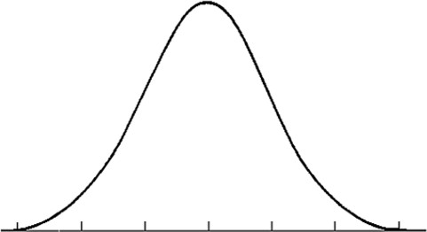
Fulfilled Performance Expectations; consistently met expectations; at times may exceed expectations

Somewhat meets and somewhat does not meet expectations; improvement needed
Consistently Exceeded Expectations; performed above and beyond

Did Not Meet Expectations
Exceptional Performance: performance far exceeded expectations

NOTE: Rows can be added or removed in each section depending on the number of employees supervised. It is possible there will not be any employees listed in every section. This information will be shared with unit administrators to make salary determinations.

List the name(s) of the employee(s) and justification(s)for exceptional performance rating.
EXCEPTIONAL PERFORMANCE
- Performance far exceeded expectations in all key areas of responsibility with exceptionally high quality of work and exceptional or unique contributions to organizational objectives
- Behavior consistently exemplified the highest values of the organization
- This rating is not given frequently.
Employee Name(s) | Justification(s)

List the name(s) of the employee(s) for each of the following ratings. No additional justification is needed on this form for employees in these areas.
SOMEWHAT MEETS/DOES NOT MEET
- Performance did not consistently meet job requirements
- Met majority but not all expectations
- Behavior may not consistently reflect the essential organizational values
- This performance rating would typically follow on-going counseling and coaching for improvement.
Employee Name(s)

FULFILLED EXPECTATIONS
- Performance consistently met expectations in key areas of responsibility; at times may exceed expectations. Overall quality of work was good
- Dependable, highly reliable, follows through on assignments
- Exhibited behavior consistent with the values of the organization
Employee Name(s)

CONSISTENTLY EXCEEDED EXPECTATIONS
- Performance consistently exceeded expectations in key areas of responsibility, and the quality of work was generally excellent
- Exhibited model behavior that reflected the values of the organization
Employee Name(s)

List the name(s) of the employee(s) and justification(s) for Did Not Meet Expectations rating. This rating should not be a surprise for the employee. You should have adequate documentation to support/show meetings and notifications to the employee about expectations not being met. For each employee listed, please note whether you have contacted IANR HR to assist you with addressing the employee’s performance concerns.
DID NOT MEET EXPECTATIONS
- Failed to meet essential performance expectations
- Lack of improvement would likely be previously documented through progressive discipline
- Behavior may be contrary to essential organizational values
- Repeated overall annual ratings of “Did Not Meet and Somewhat Meets/Does Not Meet” should not be tolerated. Improvement is essential for continued employment. A plan to improve performance must follow and include clear expectations, deadlines, and formally scheduled
one-on-one reviews for measuring the expected improvements.
Employee Name(s) | Justification(s) | IANR HR  (Y/N)

Final date to return form is March 31 or as directed by your business center.

IANR Annual Merit Recommendation Form Instructions

The IANR Annual Merit Recommendation Form (Merit Form) bridges the staff performance management process to the annual merit increase process.
Keep in mind that this is a recommendation. The final merit increase decision is made by the Unit Administrator.
Steps for Supervisors

Distribute Merit Form
  - The merit form will be sent to supervisors by their Business Centers by March 1 each year.

Complete Merit Form
  - One form should be completed per supervisor.
  - The form should be completed by the immediate supervisor using all performance-related information sources available to them since the last merit form was completed.
  - All regular staff employees supervised should be listed on the form in one of the five areas:
    - Exceptional Performance
    - Consistently Exceeded Expectations
    - Fulfilled Expectations
    - Somewhat Meets/Does Not Meet Expectations
    - Did Not Meet Expectations

Return Merit Form
  - Return the form as soon as completed, but no later than March 31.
  - Supporting documentation does not need to be attached, unless required by the Unit Administrator

Conduct Merit Conversation
  - Your Business Center will provide you with the final merit increase information.
  - Schedule a time to meet with your employees individually to let them know what their salary will be as of July 1.

Questions related to performance management and the merit form should be directed to IANR HR at ianrhr@unl.edu.

Questions related to merit amounts and the merit process should be directed to your Business Manager or the IANR Budget Office.

