All Regular employees and their managers meet to discuss six open-ended questions, focusing on employee accomplishments, goals, and opportunities for growth and development. Conversations are summarized in the Perform system.

Accessing Trakstar Perform:
- Perform.Trakstar.com

Performance Conversation Window:
January 15 – March 15

- Company Name: IANR
- Enter your UNL credentials

Performance Conversation Questions:
- Do you feel you are important to the success of your team? Yes, Somewhat or No. Please elaborate. What could you or someone else do that might increase your feeling of importance to the success of the team?
- What accomplishments have you had since our last performance conversation? What do you hope to accomplish before our next performance conversation?
- What steps will you take to develop professionally within your current role before our next performance conversation? How can I help you in this process?
- What challenges are you facing today? How can your natural strengths and talents be used to overcome these challenges?
- Do my supervisor and I think my accomplishments align with what is expected for this position and our unit’s priorities? Yes, Somewhat, or No. Please explain.
- How can I help you be your best?
Performance Conversation Process:
- Employee schedules conversation
- Employee and manager separately prep for conversation (do not submit notes in Perform)
- Face-to-face conversation takes place
- Employee summarizes conversation in Perform and submits to manager
- Manager reviews summary, adds comments and returns to employee
- Employee acknowledges manager’s review
Helpful Tips:
Don’t discuss answers prior to face-to-face conversation

Recognize accomplishments and discuss challenges

Don’t add new comments when completing summary

Work to keep answers fresh

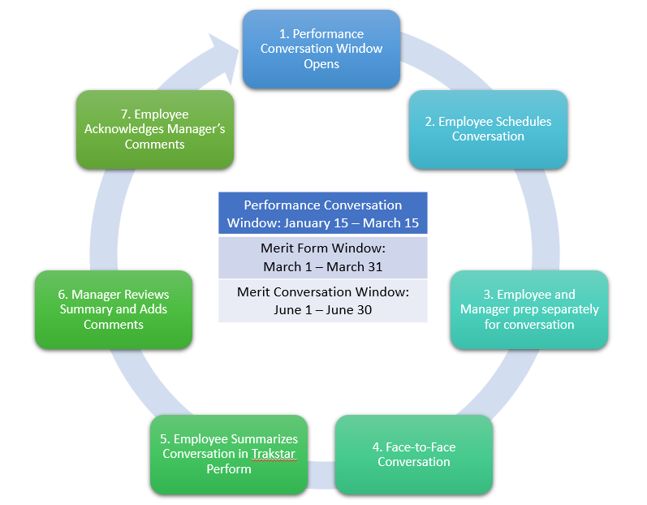

Year-Round Considerations:
- Daily Observations
- Note Accomplishments & Challenges
- Regular Check-ins
- Feedback from Customers
- Performance Improvement Conversations (if needed)

